**Lost Valley (Coire Gabhail), Glen Coe**

2/3h - 335 m

### Stage 1

Park in the large car park half way up Glen Coe at NN170569; alternatively you can park in a smaller car park a couple of hundred metres further down the glen. The car park is often busy with coaches later in the day (and often has a bagpiper), so try to arrive fairly early. There is a fabulous view of the Three Sisters across the glen.

### Stage 2

Follow the path downhill to the old track through the glen; turn left along this before following the well-worn path off to the right. This soon descends a wooden stairway to cross the River Coe, far below in its gorge. Once across the bridge the path becomes very rocky and rough, and care is needed as there have been fatalities where people have fallen into the gorge. Scramble easily up the next slope to continue on the path which heads through birch woods and pass through a gate in the deer fence before cutting round the base of Gear Aonach.

### Stage 3

The path leads into the fine wooded gorge between Beinn Fhada and Gear Aonach. The scenery is tremendous with great rock walls on each side. After some distance watch out for the place where it crosses the stream on rough stepping stones, as this spot can be easily missed. A short distance beyond here the path scrambles up a rocky rake with a steep drop on the right. The scrambling is fairly straightforward but some may find the situation airy; the rake has been well-polished by the countless walkers who have descended it on their bottoms! On the return, it is possible to avoid the rake if preferred by descending over the boulders to the left, but it would be very difficult to climb up this way.

### Stage 4

Once above the rake the path has been improved with boulders placed to form steps, and there are more open views to Glen Coe behind. Once beyond the most rugged section the path begins to descend into the 'Lost Valley'. This wide and flat expense of stones and grass is completely cut off and unsuspected from Glen Coe due to the great rock falls in the gorge below, and would have been the perfect hiding place for stolen cattle - though how they got them up here seems a mystery. Many of the Macdonalds who escaped from the massacre of Glen Coe fled here, but some perished in the winter snows.

### Stage 5

It is worth exploring the flat area of the Lost Valley, which is littered with fallen rocks the size of houses. At the head of the Glen the Munro peak of [Stob Coire Sgreamhach](https://www.walkhighlands.co.uk/munros/stob-coire-sgreamhach) is visible, but it is the great rock walls of Gear Aonach and Beinn Fhada on either side that win most attention. The return walk is by the same route.

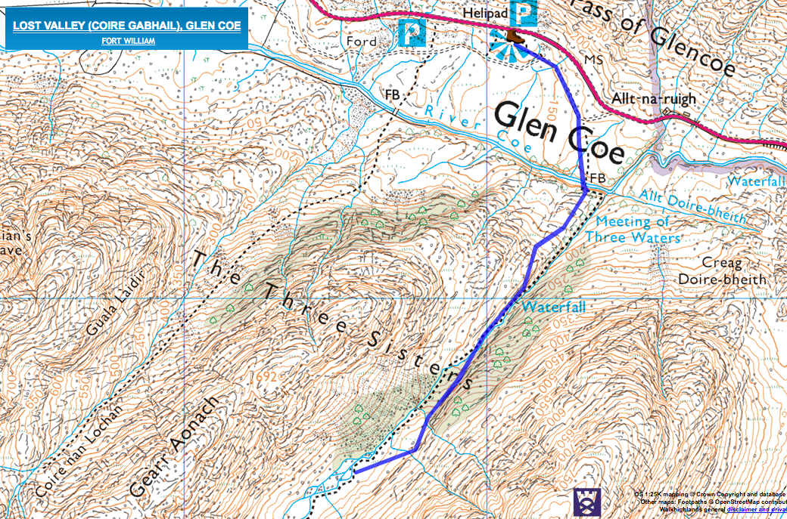

# Buachaille Etive Beag

Distance 8km / 5 miles

Time 5 - 6 hours

Ascent 900m ([Profile](https://www.walkhighlands.co.uk/fortwilliam/buachailleetivebeag.shtml#route-profile))

## Walk Description

### Stage 1

Park in one of the laybys near the cairn on the A82(T). Buachaille Etive Beag isn't shown to best effect from here; from higher up the glen the nose of Stob nan Cabar makes a lesser but still fine companion to its famous neighbour, [Buachaille Etive Mor](https://www.walkhighlands.co.uk/fortwilliam/buachailleetivemor.shtml). The walk begins along the Right of Way (signposted) through the Lairig Eilde. The path has been greatly improved by the National Trust for Scotland, and soon leads up to a fork where the Lairig Eilde route bears right; keep left here to stay on the excellent path up towards the ridge. Already there are good views of [Bidean nam Bian](https://www.walkhighlands.co.uk/fortwilliam/bideannambian.shtml) and the [Aonach Eagach ridge](https://www.walkhighlands.co.uk/fortwilliam/aonacheagach.shtml) over to the right.

### Stage 2

The path heads diagonally up the hillside for a time before aiming more directly uphill - with the aid of rocky steps - towards the Mam Buidhe, the lowest point on the ridge. Bidean nam Bian's subsidiary Munro - [Stob Coire Sgreamhach](https://www.walkhighlands.co.uk/munros/stob-coire-sgreamhach) - looks impressive from here.

### Stage 3

Eventually the gradient begins to ease and the path forks on the final approach to the bealach. To climb the highest peak - Stob Dubh - first, take the right branch in the path, continuing up steeply to reach a cairn at point 902m. From here there is a view along the ridge towards Stob Dubh, as well as down to the Lairig Gartain below the parallel ridge of Buachaille Etive Mor.

### Stage 4

The ridge narrows considerably at this point, giving a fine traverse, before the final sharper ascent up to the summit cone of Stob Dubh.

### Stage 5

It is worth continuing a short distance beyond the highest summit cairn to reach a second cairn with a sensational view into Glen Etive and to Loch Etive receeding into the infinite distance. [Ben Starav](https://www.walkhighlands.co.uk/fortwilliam/benstarav.shtml) looks very impressive to the left side of the loch, whilst in perfect weather the keen eye may pick out the Paps of Jura.

### Stage 6

Retrace your steps all along the ridge back to the bealach. To climb the second Munro, Stob Coire Raineach, continue beyond up a steep and rocky ascent with several variant paths. The climb up to the summit cairn is rough but relatively short in distance. From here there is a stunning prospect down Glen Coe.

### Stage 7

To the east and north east the tangle of peaks is lessened by the vastness of Rannoch Moor. The [Blackwater Reservoir](https://www.walkhighlands.co.uk/fortwilliam/blackwater.shtml) is very prominent.

### Stage 8

Return once more down to the bealach; care is needed with navigation to ensure a return by the ascent route if visibility is poor as several apparent paths lead onto the steep and difficulty craggy terrain of the western slopes. Once down at the bealach, retrace your steps back down the well constructed path into the Lairig Eilde and back to the start.

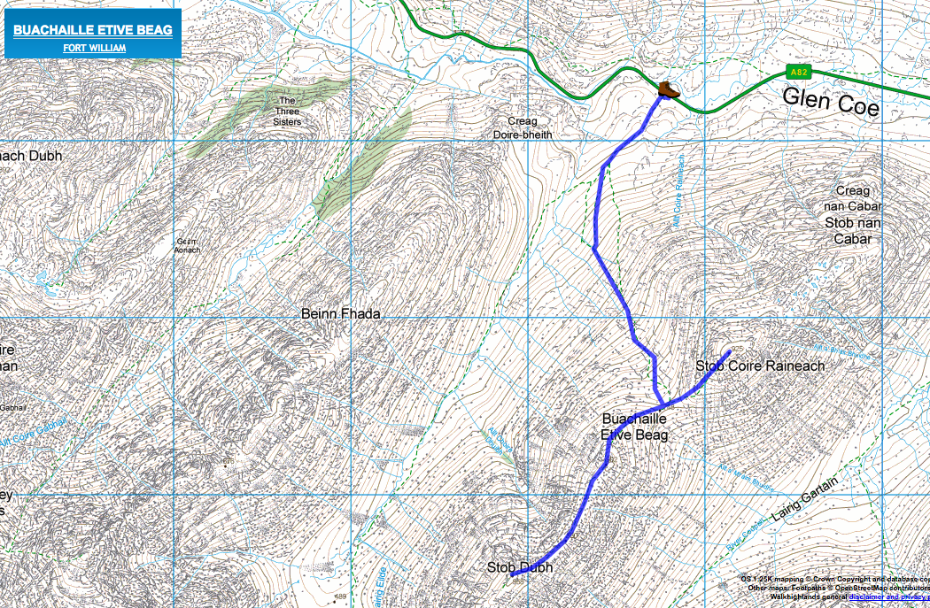

# Beinn Maol Chaluim, from Glen Etive

Distance 8km / 5 miles

Time 5 - 6 hours

Ascent 844m ([Profile](https://www.walkhighlands.co.uk/fortwilliam/beinn-maol-chaluim.shtml#route-profile))

### Stage 1

There is a gravelly layby on the north side of the Glen Etive road at NN149495, at the edge of the forestry. From here a very faint path climbs diagonally across the open grassy slope before curving more directly up the steep and wet hillside, doing its best to avoid the patches of bracken which impede parts of the slope in high summer. This first slope leading up to the ridge is rough going, with only faint traces of a path to help.

### Stage 2

The unpleasant start improves once the broad, ill-defined ridge is reached. There are good views both towards Loch Etive and [Ben Starav](https://www.walkhighlands.co.uk/fortwilliam/benstarav.shtml), and to the peaks of [Buachaille Etive Mor](https://www.walkhighlands.co.uk/fortwilliam/buachailleetivemor.shtml) and [Beag](https://www.walkhighlands.co.uk/fortwilliam/buachailleetivebeag.shtml) which appear as twins when seen from this side.

### Stage 3

Continue north across the broad, moorland ridge which undulates over several minor rises. Beyond this the route steepens once more and the ascent proper begins up a rockier slope. Any outcrops are easily avoided - the most prominent low crag being passed on the left side.

### Stage 4

Above these crags the ascent continues, finally the gradient relents by some small lochans. Continue up to point 848m. From here much of the hard work is done and the main ridge of the mountain is seen ahead, beginning with a short descent.

### Stage 5

Continue along the ridge which gives excellent views, with a particularly steep drop on the right overlooking the massive flank of [Bidean nam Bian](https://www.walkhighlands.co.uk/fortwilliam/bideannambian.shtml), whilst to the left the mountains around Glen Creran are well seen, with Loch Etive to their left.

### Stage 6

The traverse ends at a pair of summit cairns, with a sudden view down to Glencoe village and Loch Leven between the peaks. . A ridge leads north to a bealach below Bidean nam Bian but the slopes of the latter beyond deter making the link, whilst the ground leading towards to [Sgor na h-Ulaidh](https://www.walkhighlands.co.uk/fortwilliam/sgornaulaidh.shtml) has crags.

### Stage 7

The usual option, then, is to retrace the outward route back to Glen Etive.

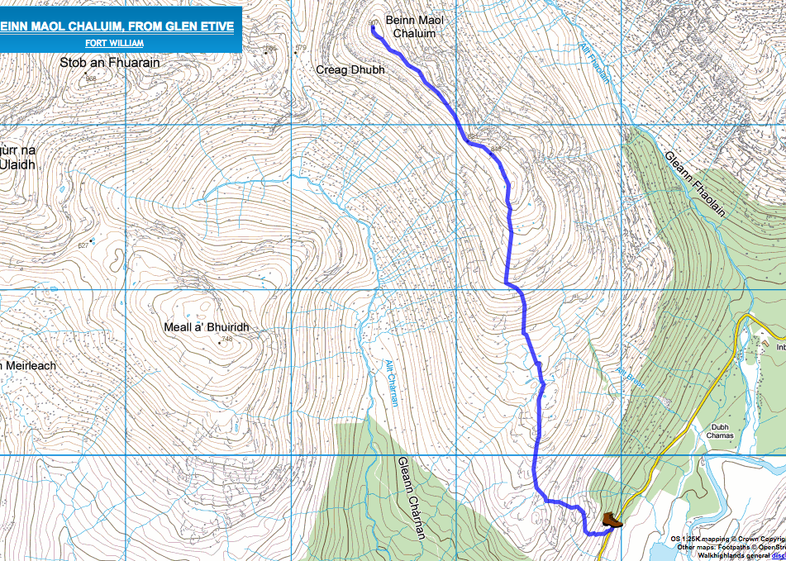

# The Pap of Glencoe

Distance 7km / 4.5 miles

Time 3.5 - 5 hours

Ascent 716m ([Profile](https://www.walkhighlands.co.uk/fortwilliam/papofglencoe.shtml#route-profile))

Known in Gaelic as Sgorr na Ciche, the Pap of Glencoe is a familiar landmark around the lower end of the glen and Loch Leven. Despite its modest height, it is a sensational viewpoint and gives a short but steep and very rough hillwalk.

### Stage 1

This walk can be started from Glencoe village, but if travelling by car it is possible to park around 400m along the minor road towards the Clachaig; there is plenty of space to park on the first section of a forest track which is on the left shortly after the electricity substation - there is space for a good number of cars. From here take the Orbital path off to the right; this runs through the trees parallel to the minor road, eventually rejoining it. Continue briefly along the road, and after passing a first gate on the left (the entrance to 'Laraichean'), go through the next gate. This leads to a track and passes straight away through another gate. Head uphill on the track, climbing past a bench with a great view up Glencoe. Before reaching the waterworks, turn right on a wide path over a footbridge.

### Stage 2

This crosses the hillside for some distance before fording a stream. Once across the stream, the path becomes narrower and curves round to the left, heading more directly uphill and coming close to the edge of the gorge above the stream. At one or two flatter sections the path has become very boggy and eroded, but it soon begins climbing once more up stonier terrain, now climbing diagonally to the right away from the stream. At about 430 metres the path swings back left and continues the climb, with more boggy sections but wonderful views over Glencoe village to Ballachulish bridge and beyond.

### Stage 3

Ignore a smaller path that turns off to the right - this is a descent route from the [Aonach Eagach](https://www.walkhighlands.co.uk/fortwilliam/aonacheagach.shtml) - and continue to the col below the Pap. The stony dome of the Pap is seen ahead.

### Stage 4

Continue on the path to its base; from here the going becomes rocky as the path makes the ascent, soon turning sharpl left and then later climbing diagonally to the right up the Pap. There are boulders and rocks en route but no real scrambling is required. As the path passes round to the back of the Pap, superb views over Loch Leven to the Mamores are revealed. Once behind the Pap the summit comes into view over to the left and the path turns to head up to it.

### Stage 5

The first, large cairn has a stunning view along Loch Leven backed by the great range over the Mamores, whilst superb views of the Ballachulish narrows and Glencoe can be had by continuing a short distance southwest across the small plateau.

### Stage 6

Once you've enjoyed the panorama, however, the descent should be made by retracing the outward route to the bealach and back down the path. This is no hardship as the views are outstanding throughout.

