# Ben More (Mull) from Dhiseig

Distance 9.25km / 5.75 miles

Time 5 - 6.5 hours

Ascent 945m ([Profile](https://www.walkhighlands.co.uk/mull/ben-more-mull.shtml#route-profile))

Start Grid Ref NM494359

**Stage 1**

Opposite the track for Dhiseig there is a large parking area on grass, just east of a bridge, on the shore side of the A8035. Start by heading up the track passing the sign for the Benmore footpath and keeping straight ahead at the entrance to the house at Dhiseig, following the sign that just says 'up'.

**Stage 2**

Head straight through a gate and then bear slightly right to follow a path alongside the Abhainn Dhiseig which tumbles down in a small gorge. As you climb the views behind of Ulva and other smaller islands improve. At a fence bear left to follow it to a gate and go through the gate. Here two sets of paths have been worn both of which converge higher up the hill, either bear right to continue to follow the Abhainn Dhiseig or follow the worn ground straight ahead SSE - the latter route is boggier and slightly less attractive.

**Stage 3**

Soon the top of the peak of Ben More can be seen directly ahead, with the flank of An Gearna on the left to the east. Aim directly for Ben More, crossing a side stream at a clear crossing point with a worn path ignoring the path that branches off towards An Gearna. Soon the path runs alongside the Abhainn Dhiseig passing some very ruined buildings - marked on the map, but now only piles of stones, and then crossing the stream at an easy spot to continue uphill on the far side.

**Stage 4**

Pass a series of waterfalls on the left and follow the path, which becomes increasingly stony and eroded as you climb. The path keeps fairly close to the stream at first, but it is also possible to head directly up the more grassy ground to the right or southwest. As the ridge becomes more defined, a series of small cairns marks the clear path, which is now stony and scree-covered in places. On the steepest ground it ascends in small zig zags until the gradient eases onto the summit ridge.

**Stage 5**

From here the views become much more dramatic, with the ridge route from [A' Chioch](https://www.walkhighlands.co.uk/mull/ben-more-a-chioich.shtml) coming into view. Follow the ridge southeast to reach the large summit shelter and tiny stumps of the remains of the trig point at 966m. To the south the ridge extends dramatically whilst just to the south of the summit is the start of the scramble route heading eastnortheast to A'Chioch.

**Stage 6**

On a clear day the mainland summits such as Ben Cruachan can clearly be seen and there are great views over most of Mull and to Ulva. Whilst it is possible to descend via A'Chioch this route is much better and easier as an ascent route up Ben More. The easiest and quickest route back is to retrace your outward steps to return directly to the road.

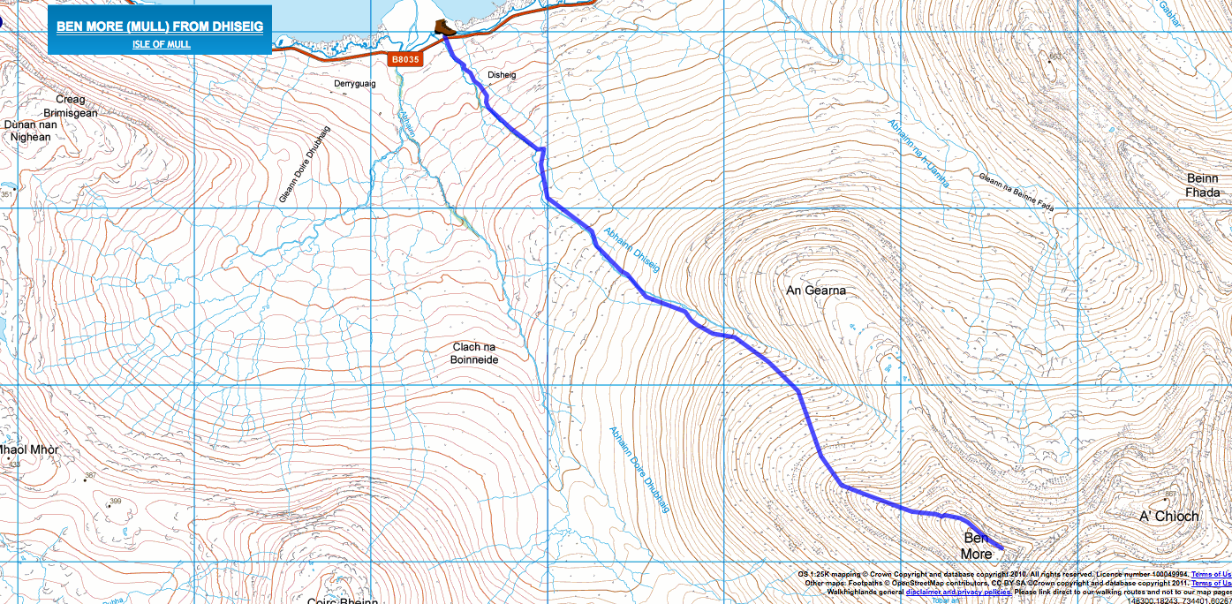

# Cnoc na Sroine, Salen

This very enjoyable walk from Salen follows a lovely rising grassy track to Glenaros House, with fine views over the Sound of Mull. It then climbs over the rougher moors, visiting an iron-age fort with a superb outlook, before turning to Salen via some attractive native woodland.

Distance 6.25km / 4 miles

Time 2 - 2.5 hours

Ascent 176m ([Profile](https://www.walkhighlands.co.uk/mull/salen.shtml#route-profile))

## Walk Description

### Stage 1

Park by the public toilets in Salen, on the Tobermory road. The walk begins by heading north along the road verge, taking care as the road can be busy even though it is single track. There are lovely views over Salen Bay to the right, with some wrecked boats providing an attractive foreground; look out for otters too. After passing an old jetty look out for a gate on the left side of the road; it has a sign 'Footpath to Glenaros Farm'.

### Stage 2

Go through the gate to head along a grass-grown lane. It climbs slightly and runs through very beautiful native woodland, and soon gives superb views up the Sound of Mull and towards Aros Castle; this section of the walk is delightful. The lane - which has become faint - passes through three farm gates before the impressive Glenaros Farm house becomes visible ahead. As it is approached pass through two more gates to keep well left of the main house, joining a surfaced track right by the old white farmworkers cottage to the left of the other farm buildings.

### Stage 3

Go straight across this track and through another gate opposite; the field on the other side is initially very muddy. Bear left and soon a very rough track becomes clear to follow; it climbs gently keeping a drystone dyke to your left to begin with. Continue across the rough moor and grassland, soon fording a small burn. Ahead is a grassy knoll marked by a cairn on the left side of its summit; this is Cnoc na Sroine, the site of an iron age fort. Continue on the path which climbs to the right of the knoll. Once close to it turn left off (there are faint traces of a path) to make a detour to visit it.

### Stage 4

After a final steep rise the top of the hillock is reached. Whilst the cairn is probably modern, there are very clear remains of the thick defensive walls which enclosed a surprisingly large area; the courses of stonework are still visible in places which is a testament to the skill of the builders. The fort is a fine viewpoint; after visiting it cut carefully back downhill to return to the main path, and continue along it. It climbs slightly before reaching its highest point and beginning a slow descent - boggy in places.

### Stage 5

Keep left as you pass a big wooden marker and follow the clear path downhill just left of some fragments of birchwood; a different route to the path marked on OS maps which they show heading into the forestry on the right. The path eventually meets another running across the hill. Turn left onto this; it climbs slightly at first. While passing through the native woodland fragments at Doire nam Pioghaid it becomes very boggy for a time and it is necessary to detour in places to avoid the worst of the mud.

### Stage 6

The path eventually improves once more and runs across a more open area, eventually with views to Salen. Soon Airigh Mhic Dhomnuill is reached - a fine native woodland with a mix of mighty oak trees and birches. Finally the path descends through the trees to emerge in Salen beside the old church. Turn right along the main road to reach the start of the walk.

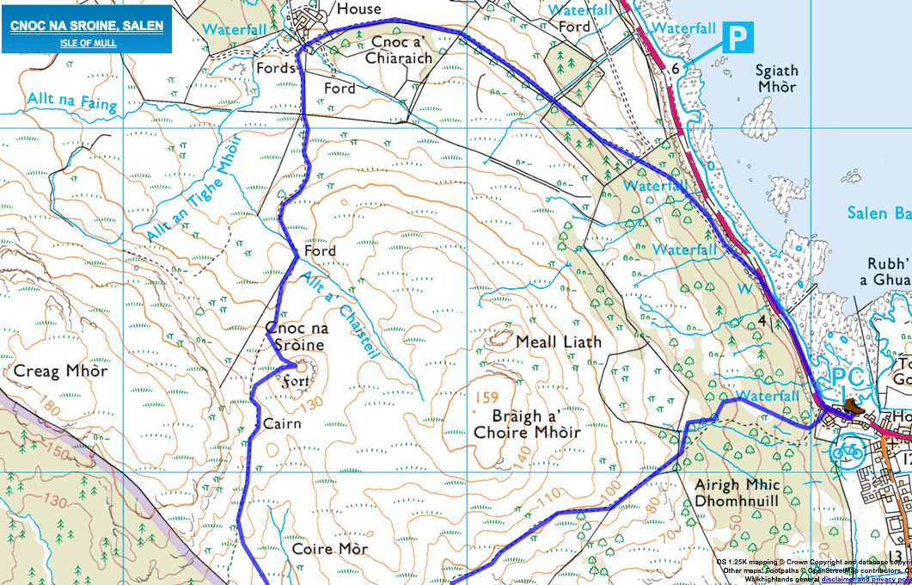

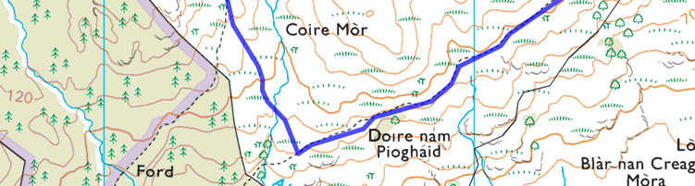

# Quinish Point, from Dervaig

This excellent walk heads out onto the Quinish peninsula from Dervaig, through woods and pastures and passing a magnificent standing stone. The destination of this out-and-back excursion is Quinish Point - a headland offering superb seascapes on a clear day, taking in Coll, Rum, Skye and even the Outer Hebrides.

Distance 12.75km / 8 miles

Time 3 - 4.5 hours

**Stage 1**

The walk begins from Dervaig, past the picturesque cottages and shop on the branch road that leads to Cuin. This is a public road and so can be driven for a kilometre or so from Dervaig, but there is no parking at the end so it is best to walk it from the village. From Cuin continue on the main track, soon crossing a cattle grid. Keep straight ahead through the 'Quinish' gateposts into the woods, ignoring the track which curves up to the houses on the right.

**Stage 2**

The woodland is very attractive, and after around a further kilometre or two follow the main track as it curves right at a junction (ignoring two smaller tracks on the left). The track soon leads up to the Home Farm and passes the buildings on the right. The route forks just beyond; keep straight ahead here and ignore the main track to the right.

**Stage 3**

Keep ahead again at the next junction, ignoring the left branch to Quinish House. The track leads through a couple of gates before the woods are left behind; good views open up over the pastures to the sea beyond. Ignore a track branching left and stay on the main route which climbs gently.

**Stage 4**

Further on the track forks again; the route to Quinish is once more the right-hand, uphill branch, but it is worth making a short detour ahead to visit the standing stone. There are four stones here though only one remains upright, standing to a height of over 9 feet. Back on the route, follow the track which climbs up to the right. When a faint track goes ahead through a gate, remain on the main track to the right, itself soon leading through a gate before bending left on the far side of the wall.

**Stage 5**

The track now descends gently with views to Mingarry. Pass through a gate some distance short of the house and then leave the main track, bearing left through the field on a faint grassy track (signed 'Quinish Point'). This passes below some crags on the right and leads through another gate before descending with views over the sea to [Coll](https://www.walkhighlands.co.uk/islands/coll.shtml) ahead, over the hillock of Dun Ban. Stay on the track as it swings to the right and then leads on to Dun Dubh, a second hillock which marks Quinish Point itself. There are stunning views ahead to the Isle of Rum and its Cuillin, with the [Cuillin of Skye](https://www.walkhighlands.co.uk/skye/cuillin.shtml) visible to its right. On a good day [Eaval](https://www.walkhighlands.co.uk/outer-hebrides/eaval.shtml) and the Lee hills can be picked out on [North Uist](https://www.walkhighlands.co.uk/outer-hebrides/north-uist.shtml).

**Stage 6**

Climb up onto the top of Dub Dubh for the best vantage points, right out on the point; a wonderful spot for a picnic on a fine summers day. The return walk is a retracing of the outward journey, but if you don't mind wet feet you could return beside the shore as far as Dun Ban, which was the site of a fort in the Iron Age. From here head back left to rejoin the main track rather than attempting to continue by the shore, and follow the outward route back to Dervaig.

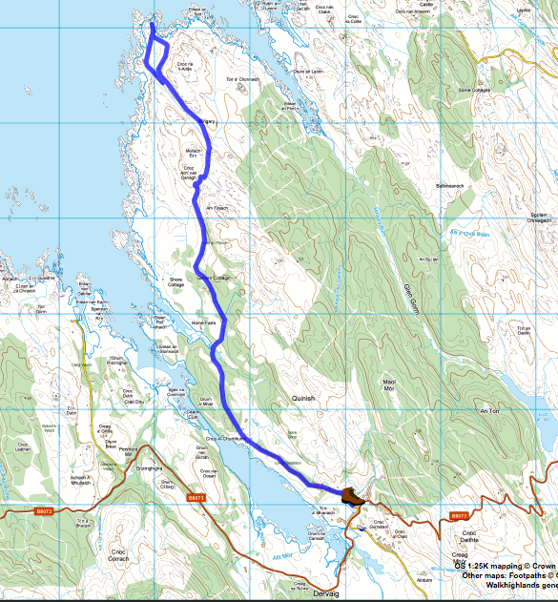

# Crater Loch: Lochan 's Airde Beinn

3km / 2 miles

1,5 hour

**Stage 1**

The walk starts from the B8073 Tobermory to Dervaig road. There is a small layby at the start, just before a ruined house if travelling from Tobermory, just west of the edge of the forestry plantation. This can take 2 cars, if there is no room, park in an old quarry about 500 metres further down the road towards Tobermory, do not block any passing spaces. From the layby climb the stile (**NB: stile is currently missing**) and bear slightly left uphill through bracken in summer until the path becomes clearer. The path heads uphill from the back of the ruined cottage, keeping the plantation edge well to the right.

**Stage 2**

Soon the volcanic hill of 'S Airde Beinn can be seen looming ahead. 60 million years ago, Mull was at the height of a period of volcanic activity that also formed the columns at Staffa and elsewhere on the coast. Go through a gate and continue up the path. This section is often very boggy.

**Stage 3**

When the path forks keep straight ahead, the path to the right is the return route. Now the steepest section leads to the top of the hill. From the top keep left to follow the edge of the crater all the way round.

**Stage 4**

There are excellent views in all directions. At the dip before the final rise that would bring you back to the start of the circuit, cross the outflow of the lake and follow the faint path down to the right following the stream.

**Stage 5**

The path is rocky in places and keeps to the right of the stone wall. Eventually it curves right and rejoins the outward path down to the start.

