**The Storr - ascent**

Distance 8km / 5 miles

Time 3.5 - 5 hours

Ascent 640m ([Profile](https://www.walkhighlands.co.uk/skye/thestorr.shtml#route-profile))

A spectacular walk to a famous summit, passing through the iconic landscape of the Sanctuary with the Old Man of Storr and many other rock formations. The route then heads on up to the summit, giving superb views in all directions.

## Start

Storr car park on the left side of the A855 heading from Portree.

### Stage 1

The Storr is the craggy summit atop the grand cliffs behind the famous pinnacle of the Old Man of Storr. Its ascent in the later stages escapes from initial busy paths round the [Old Man of Storr](https://www.walkhighlands.co.uk/skye/old-man-of-storr.shtml) and offers spectacular views. Park at the Storr car park or the layby alongside - both are often very busy. The path starts through the gate by the information board.

### Stage 2

The excellent path winds uphill through the felled area - which will eventually become native woodland. This section was once a quagmire but follow a series of improvement projects can now be done with dry feet. There are views of the [Isle of Raasay](https://www.walkhighlands.co.uk/skye/isle-of-raasay.shtml) offshore and [Applecross](https://www.walkhighlands.co.uk/torridon/applecross.shtml) on the mainland beyond. Keep right at both of two forks (the path on the left is an alternative loop). Eventually the path passes through a gate and leaves the felled area to reach the open moor with the spectacular cliffs of the Storr up ahead.

### Stage 3

The Old Man can be difficult to pick out from the cliffs behind from this point. Continue up the pitched stone footpath. Ignore a branch to the left and continue on the path climbing towards the right side of the Old Man. When nearly at the Old Man, follow a fainter (but still clear) path off right diagonally up the moor towards the end of the line of cliffs, passing below the Cathedral Rock.

### Stage 4

This eventually reaches a fence with a broken stile. The view back from here to the Old Man and the Cathedral rock, backed by the Storr Lochs, is a classic. Over the stile, follow the path round to the left. It forks as it approaches a rocky band - the left fork gives slightly the easier way up this scrambly obstacle. (If you fancy a more adventurous route to the summit from here, double back left and follow the edge of the buttresses towards the summit, with great views down the gullies. The final rockwall below the summit is bypassed to the right, where a short easy scramble leads to a grassy gap in the cliffs near the summit. Great care is needed on this route as the cliffs are very unstable) Otherwise, follow the almost level path in a wide arc around Coire Scamadal. There are views up the coast northwards towards Staffin.

### Stage 5

About a kilometre on, when the grass slopes to the left have become lower and free of rocks, break off from the path up these slopes to reach the escarpment ridge. Turn left along this ridge, climbing gently to reach the summit of The Storr, marked by a trig point. The views are superb. The Trotternish Ridge stretches away to the north, backed by the hills on the Isle of Harris. East are the islands of [Raasay](https://www.walkhighlands.co.uk/skye/isle-of-raasay.shtml) and Rona, with a spectacular array of mainland peaks beyond. To the south are the jagged [Cuillin](https://www.walkhighlands.co.uk/skye/cuillin.shtml) mountains and much of the rest of Skye, whilst west the flat-topped Macleod's Tables are the most prominent landmarks.

### Stage 6

Follow the edge of the great cliffs (keeping a safe distance) - slightly south of west at first before turning south east after passing the head of a wide, steep scree gully. Ignore this gully and continue along the escarpment downhill. There are soon excellent views across the strange landscape of the Storr Sanctuary and the Old Man below. The escarpment then turns again to the right.

### Stage 7

Continue WSW along it (becoming less distinct) until reaching a gully where a stream descends the cliffs (make sure it is the gully with the stream as other routes may lead into difficulties). The way down the cliffs is on the near side of this stream - it is steep and stony but has no difficult obstacles. Once below the cliffs, continue descending SE, keeping fairly near the edge of the felled forest for most of the lower section. When the road can clearly be seen head slightly to the right to aim for a small parking area behind a gate which leads to the main road. Note that there is no longer a stile on the fence at the edge of the forest. Head north by turning left along the road for 500m to reach the car park.

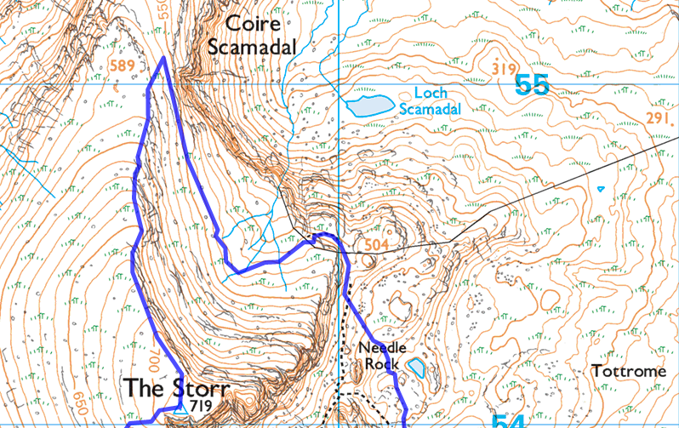

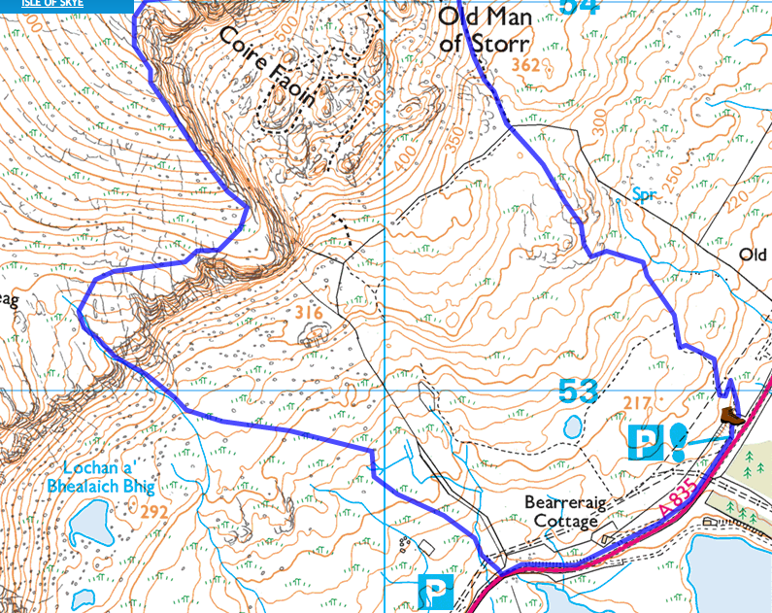

**Coire Lagan**

Distance 9km / 5.75 miles

Time 3 - 5 hours

Ascent 590m ([Profile](https://www.walkhighlands.co.uk/skye/coirelagan.shtml#route-profile))

## Start Parking at Glen Brittle above the beach

### Stage 1

Park just before the campsite at the end of the Glen Brittle road. The sandy beach here gives spectacular views of the peaks behind Coire Lagan, looking particularly beautiful when lit by the last rays of afternoon sun. The walk starts up the prominent path just left of the campsite toilet block. The early part of the route was once an eroded swamp, but following extensive works there is now an excellent pitched-stone constructed footpath. Go straight across when the path crosses a rough track.

### Stage 2

As height is gained, great views open up of the [Isle of Rhum](https://www.walkhighlands.co.uk/islands/isle-of-rum.shtml) and, later, [Eigg](https://www.walkhighlands.co.uk/islands/eigg.shtml). Ignore a path heading right across a burn - this leads to [Coire Ghrunnda](https://www.walkhighlands.co.uk/skye/sgurrnaneag.shtml). After passing a large cairn (a path goes off to the left here, which will be used in descent) the ground becomes rougher.

### Stage 3

The hardest part is where the path heads up a gully between two slabs of rock, the rocks in the gully bed and walls providing a simple scramble up a rocky staircase. The burn cascades over great grey slabs of gabbro to the right.

### Stage 4

After the gully, the Loch is only short distance beyond. The small and beautiful blue lochan is surrounded by great sweeps of rock. There are huge slabs, vertical precipices and gigantic stone chutes all around. It is immediately obvious that going higher would be much more difficult than the route so far, and many walkers will be content to make a circuit of the loch and linger here.

### Stage 5

Cross the outflow of the loch to begin the walk around it. The screes on the left are topped by the jagged spire of the [Inaccessible Pinnacle](https://www.walkhighlands.co.uk/skye/innpinn.shtml), the UK's most difficult mountain, though the summit is out of sight. To the right of this the screes lead right up to the ridge before the next great craggy peak [Sgurr Mhic Choinnich](https://www.walkhighlands.co.uk/skye/sgurr-mhic-choinnich.shtml), first climbed by the local guide John Mackenzie after whom it is named.

### Stage 6

Further right is Sgurr Thearlaich, a fang of rock accessible only to rock climbers, and then [Sgurr Alasdair](https://www.walkhighlands.co.uk/skye/sgurralasdair.shtml), the highest mountain in Britain outwith the mainland. The last real peak is Sgurr Sgumain and then the great rock wall of Sron na Ciche, rising from beneath the corrie is The Cioch - a dramatic rock pinnacle jutting out from the face - can be hard to pick out but is sometimes well seen if the shadows are right.

### Stage 7

The return walk heads back down the path, including the scrambly gully, to reach the large cairn mentioned earlier. To vary the route, bear right here. This path, greatly improved and reconstructed in 2007, replaces the once eroded and boggy route as it passes Loch an Fhir-Bhallaich

### Stage 8

and later passes alongside the Eas Mor falls, where a stream plunges over a cliff into a deep ravine. The path continues descending and crosses a footbridge before emerging on the Glen Brittle road near the mountaineering club hut. Turn left along the road to return to the star

